Muscle Tonus Report

The following report is an analysis of the muscle load test performed at Plux on 26/09/2016

The EMG electrodes were placed using the posterior superior iliac spine as an anatomical marker. Figure 1 shows the placement over the *multifudus* and the *erector spinae* muscles on both sides of the spine.

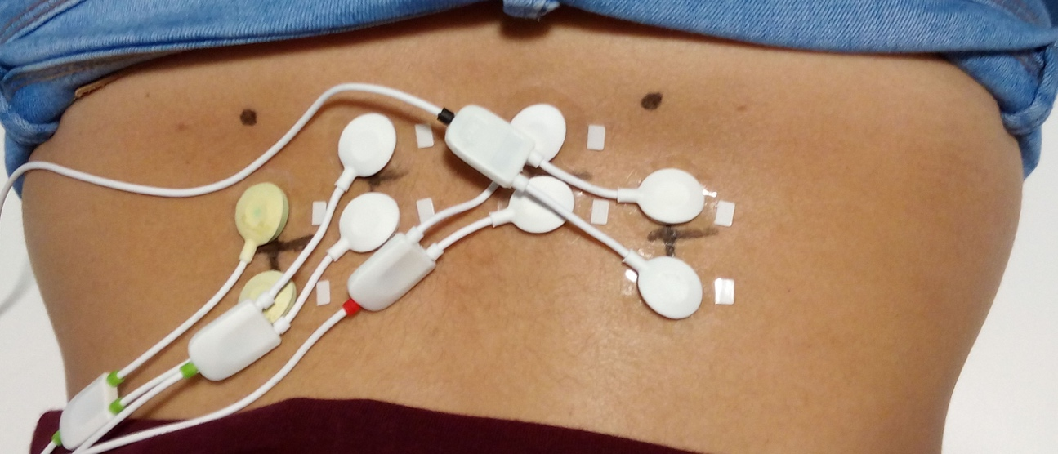

Figure 1 - Position of the EMG leads

# Procedure

Six different tests were recorded:

* Rest: Data recorded with the test subject laying down on a table, with their back facing up;
* Arms Extension: Same position as the rest test, but with the test subject arms extended forwards, parallel with their head;
* MVC: While holding the test su